Z1 wynik:
Metoda | MSE
Gradient prosty | 4.0542
Scikit-learn | 4.0648

Cechy | Wagi (Gradient prosty) | Wagi (Scikit-learn)
num__age | 3.0177 | 3.0585
num__value_eur | 0.6179 | 0.6425
num__potential | 3.5130 | 3.5171
num__height_cm | 0.1980 | 0.2154
num__weight_kg | 0.2087 | 0.2184
num__pace | 0.4690 | 0.4518
num__shooting | 0.1494 | 0.1525
num__passing | 0.3135 | 0.3208
num__dribbling | 1.4750 | 1.4750
num__defending | 0.6361 | 0.6556
num__physic | 0.9082 | 0.9468
cat__preferred_foot_Right | -0.0287 | -0.0224

Fold | MSE | R²
Fold 1 | 4.0880 | 0.9107
Fold 2 | 4.1969 | 0.9086
Fold 3 | 4.2157 | 0.9082

Średnie (±SD) | Wartość
MSE | 4.1668 ± 0.0563
R² | 0.9092 ± 0.0011

Z2
polynomial features dla linear regression dla cechy “value”
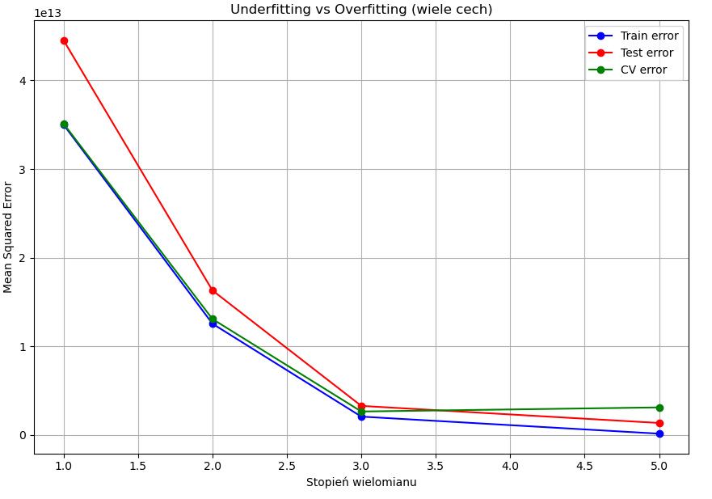
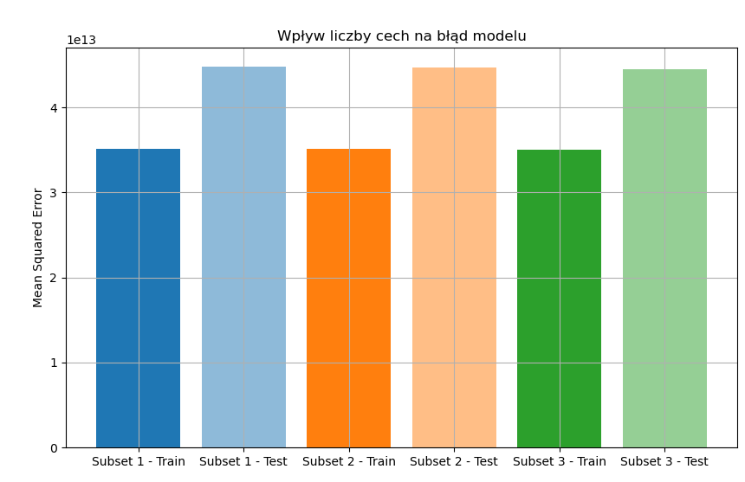
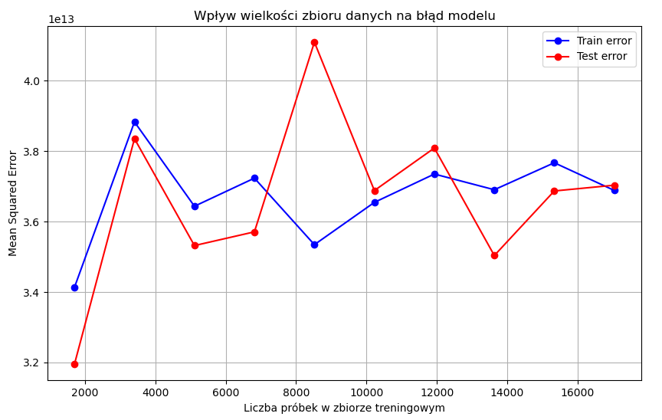
Dla cechy overall:
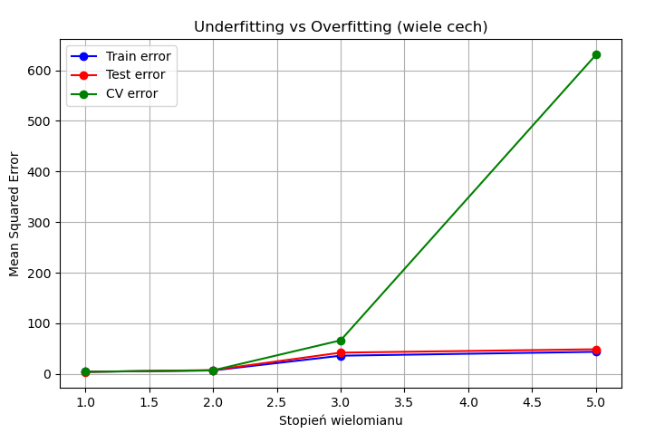
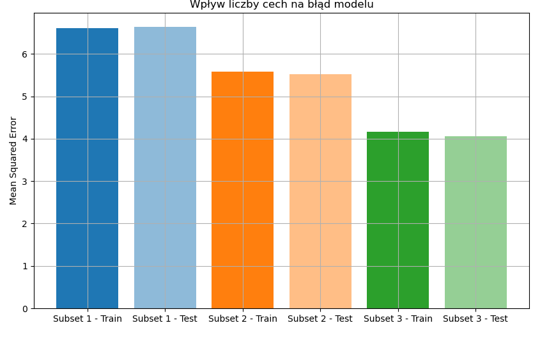
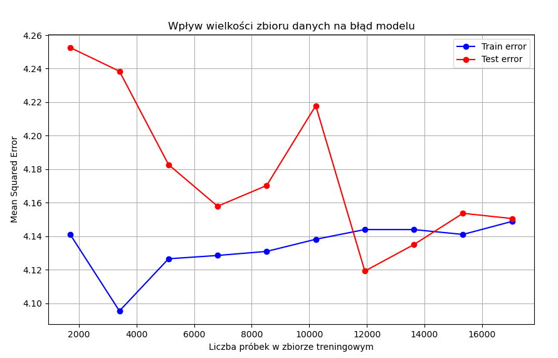
Proces uczenia dla implementacji gradient
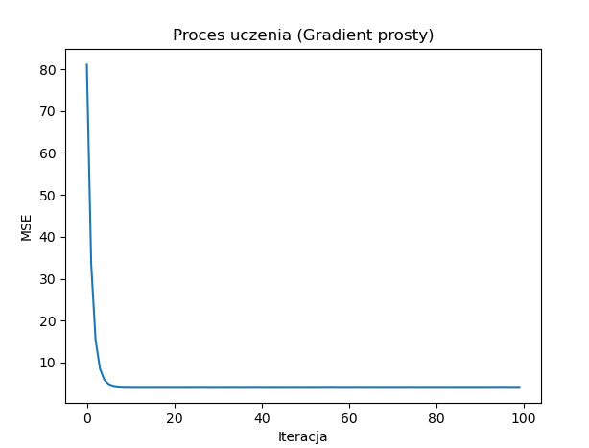
ilość cech a wynik:
Subset 1: Train MSE = 7.1970, Test MSE = 7.1070
['age', 'overall', 'potential']

Subset 2: Train MSE = 6.0028, Test MSE = 5.7719
['age', 'overall', 'potential', 'pace', 'shooting', 'passing']

Subset 3: Train MSE = 4.1768, Test MSE = 4.0536
Wszystkie cechy
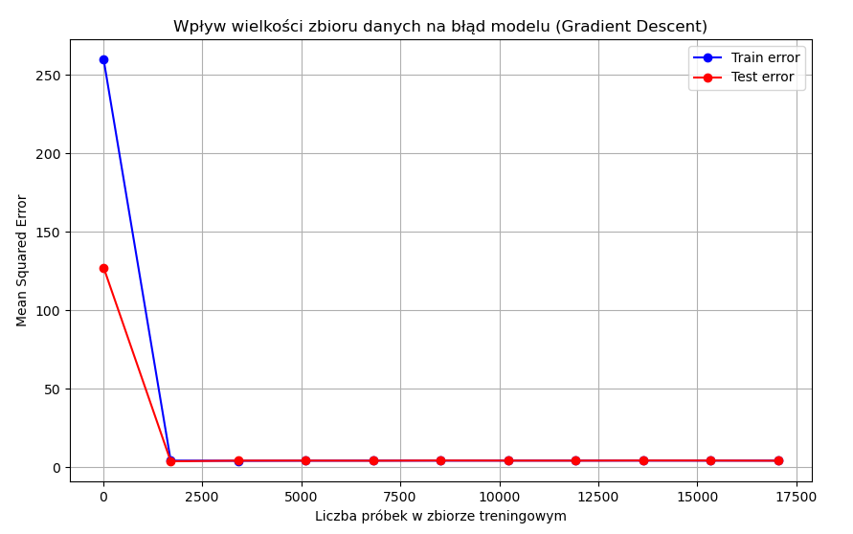
Z3
Regularyzacja na regresji liniowej sklearn
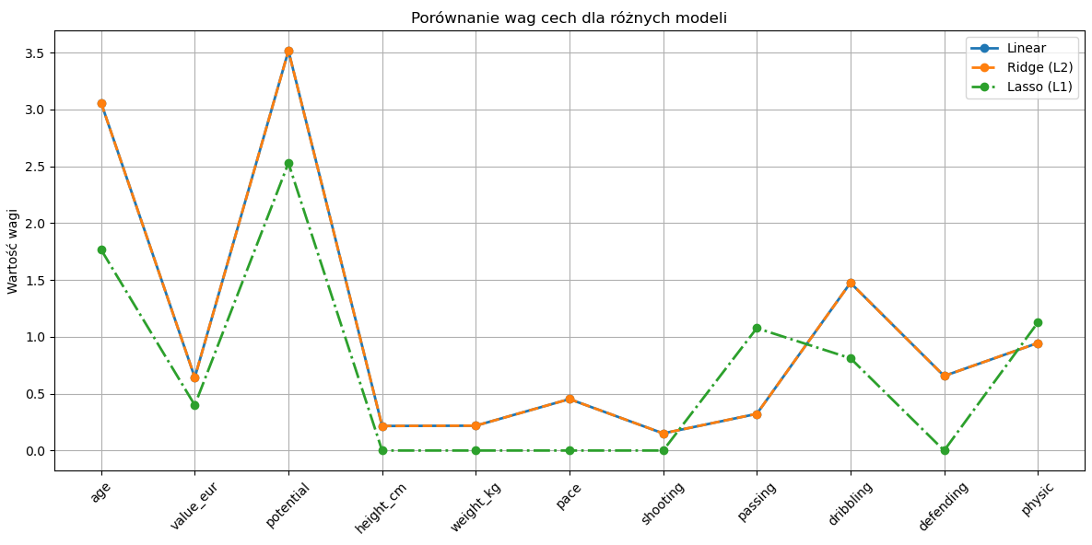
Model | Mean Squared Error (MSE)
Linear | 4.07
Ridge (L2) | 4.07
Lasso (L1) | 7.09

Cecha | Linear | Ridge (L2) | Lasso (L1)
age | 3.0588 | 3.058 | 1.7667
value_eur | 0.6423 | 0.6425 | 0.3996
potential | 3.5171 | 3.5163 | 2.5285
height_cm | 0.2161 | 0.216 | 0
weight_kg | 0.2185 | 0.2186 | 0
pace | 0.4526 | 0.4526 | 0
shooting | 0.1507 | 0.151 | 0
passing | 0.3225 | 0.323 | 1.0765
dribbling | 1.4753 | 1.4751 | 0.8117
defending | 0.6559 | 0.656 | 0
physic | 0.9458 | 0.946 | 1.1257

Dodane L2 do gradientu
Cecha | Gradient prosty | Gradient prosty + L2
num__age | 3.0931 | 2.3130
num__value_eur | 0.5914 | 0.7821
num__potential | 3.4921 | 2.7550
num__height_cm | 0.2152 | 0.2175
num__weight_kg | 0.2186 | 0.3040
num__pace | 0.4242 | 0.3989
num__shooting | 0.1640 | 0.3543
num__passing | 0.3438 | 0.6996
num__dribbling | 1.4826 | 1.3098
num__defending | 0.6615 | 0.7715
num__physic | 0.9477 | 1.0908
cat__preferred_foot_Right | -0.0383 | -0.0417
Z4 metryki ewaluacji
Precision (precyzja) – odsetek trafnie przewidzianych pozytywnych przypadków spośród wszystkich przewidzianych jako pozytywne.
Recall (czułość) – odsetek trafnie przewidzianych pozytywnych przypadków spośród wszystkich rzeczywistych pozytywnych przypadków.
F1-score – średnia harmoniczna precision i recall, która równoważy obie metryki.

Oryginalny zbiór danych
Klasa | Precision | Recall | F1-score | Support
0 | 0.0000 | 0.0000 | 0.0000 | 864
1 | 0.7465 | 0.9996 | 0.8547 | 2545

Metryka | Wartość
Accuracy | 0.7463
Macro avg (P/R/F1) | 0.3732 / 0.4998 / 0.4273
Weighted avg (P/R/F1) | 0.5573 / 0.7463 / 0.6381

Oversampling (SMOTE)
Klasa | Precision | Recall | F1-score | Support
0 | 0.3234 | 0.6678 | 0.4358 | 864
1 | 0.8234 | 0.5257 | 0.6417 | 2545

Metryka | Wartość
Accuracy | 0.5617
Macro avg (P/R/F1) | 0.5734 / 0.5968 / 0.5388
Weighted avg (P/R/F1) | 0.6967 / 0.5617 / 0.5895

Undersampling
Klasa | Precision | Recall | F1-score | Support
0 | 0.3247 | 0.6644 | 0.4362 | 864
1 | 0.8233 | 0.5308 | 0.6455 | 2545

Metryka | Wartość
Accuracy | 0.5647
Macro avg (P/R/F1) | 0.5740 / 0.5976 / 0.5408
Weighted avg (P/R/F1) | 0.6969 / 0.5647 / 0.5924

Z5
Najlepsze parametry dla DecisionTreeRegressor:
{'model__max_depth': None, 'model__min_samples_split': 10}
Decision Tree
- GridSearch:
  - MSE: 3 899 232 167 050.69
  - RMSE: 1 974 647.35
  - R2: 0.94
- Default:
  - MSE: 4 028 854 068 875.55
  - RMSE: 2 007 200.56
  - R2: 0.94

Najlepsze parametry dla RandomForestRegressor:
{'model__max_depth': 10, 'model__min_samples_split': 2, 'model__n_estimators': 100}
Random Forest
- GridSearch:
  - MSE: 2 209 401 625 175.56
  - RMSE: 1 486 405.61
  - R2: 0.96
- Default:
  - MSE: 2 298 936 019 820.17
  - RMSE: 1 516 224.26
  - R2: 0.96

